Prepare rules for the all the data sets

1) Try different values of support and confidence. Observe the change in number of rules for different support,confidence values

2) Change the minimum length in apriori algorithm

3) Visulize the obtained rules using different plots

**Ans :**

**R Code :**

## Association Rules

## Association Rules

########## movies Data Set #########

library(arules)

movies<-read.transactions('D:\\Data Science\\Excelr\\Assignments\\Assignment\\Association Rules\\my_movies_r.csv',format="basket")

inspect(movies[1:10])

class(movies)

# itemFrequencyPlot can be applicable only for transaction data

# count of each item from all the transactions

itemFrequencyPlot(movies,topN=20)

movies_rules<-apriori(movies,parameter = list(support = 0.002,confidence = 0.05,minlen=3))

library(arulesViz)

plot(movies_rules,method = "scatterplot")

plot(movies_rules,method = "grouped")

plot(movies_rules,method = "graph")

plot(movies_rules,method = "mosaic")

inspect(movies_rules[1:5])

rules <- sort(movies_rules,by="lift")

inspect(rules[1:4])

## With different support, confidence and minimum length ##

movies_rules1<-apriori(movies,parameter = list(support = 0.003,confidence = 0.06,minlen=4))

plot(movies_rules1,method = "scatterplot")

plot(movies_rules1,method = "grouped")

plot(movies_rules1,method = "graph")

plot(movies_rules1,method = "mosaic")

inspect(movies_rules1[1:5])

rules1 <- sort(movies_rules1,by="lift")

inspect(rules[1:4])

**Results :**

> movies_rules<-apriori(movies,parameter = list(support = 0.002,confidence = 0.05,minlen=3))

Apriori

Parameter specification:

confidence minval smax arem aval originalSupport maxtime support minlen maxlen target ext

0.05 0.1 1 none FALSE TRUE 5 0.002 3 10 rules FALSE

Algorithmic control:

filter tree heap memopt load sort verbose

0.1 TRUE TRUE FALSE TRUE 2 TRUE

Absolute minimum support count: 0

set item appearances ...[0 item(s)] done [0.00s].

set transactions ...[15 item(s), 11 transaction(s)] done [0.00s].

sorting and recoding items ... [15 item(s)] done [0.00s].

creating transaction tree ... done [0.00s].

checking subsets of size 1 2 3 4 done [0.00s].

writing ... [22 rule(s)] done [0.00s].

creating S4 object ... done [0.00s].

**## With different support, confidence and minimum length ##**

> movies_rules1<-apriori(movies,parameter = list(support = 0.003,confidence = 0.06,minlen=4))

Apriori

Parameter specification:

confidence minval smax arem aval originalSupport maxtime support minlen maxlen target ext

0.06 0.1 1 none FALSE TRUE 5 0.003 4 10 rules FALSE

Algorithmic control:

filter tree heap memopt load sort verbose

0.1 TRUE TRUE FALSE TRUE 2 TRUE

Absolute minimum support count: 0

set item appearances ...[0 item(s)] done [0.00s].

set transactions ...[15 item(s), 11 transaction(s)] done [0.00s].

sorting and recoding items ... [15 item(s)] done [0.00s].

creating transaction tree ... done [0.00s].

checking subsets of size 1 2 3 4 done [0.00s].

writing ... [4 rule(s)] done [0.00s].

creating S4 object ... done [0.00s].

**Plots :**

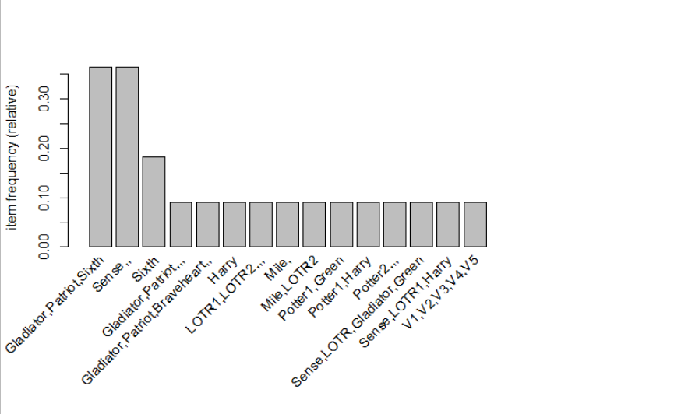

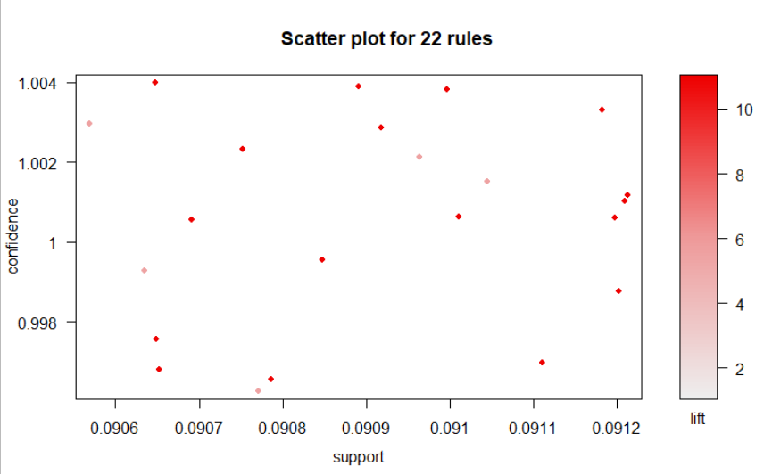

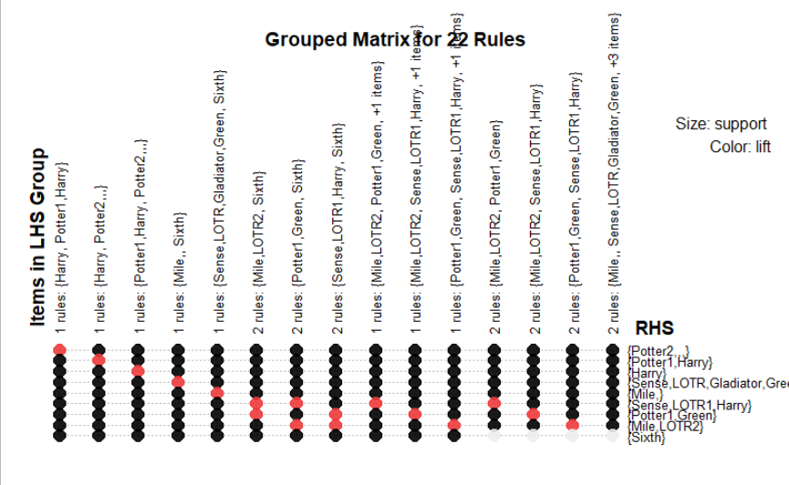

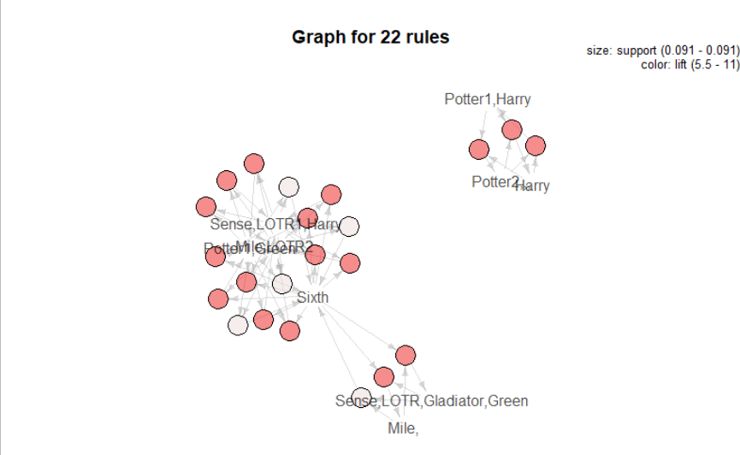

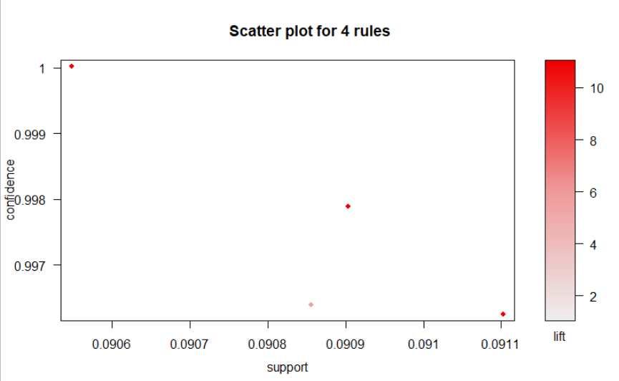

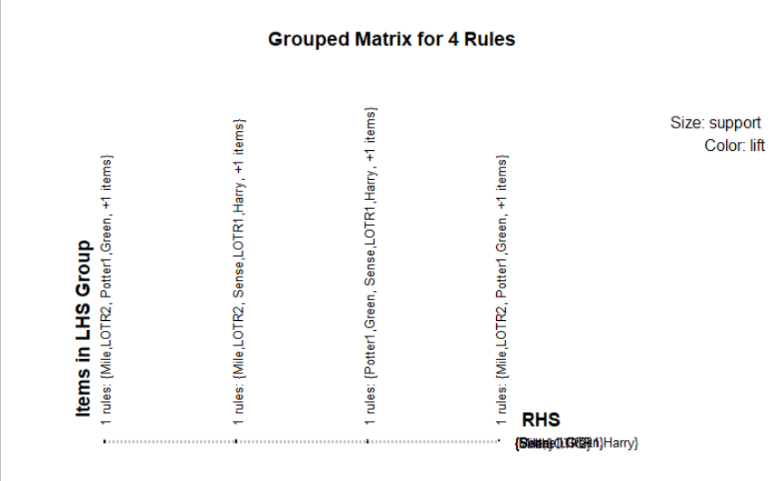

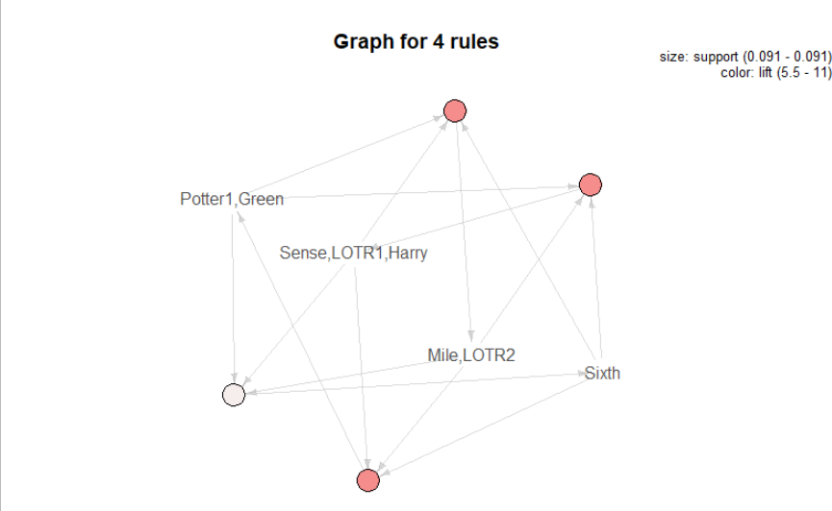

**Inference :**

There were 22 rules generated when we kept, support = 0.002,confidence = 0.05,minlen=3.

And, there were 4 rules generated when we kept, support = 0.003,confidence = 0.06,minlen=4.